**FiteMiiIRL User Manual**

**Homepage:**

On this page you can go to create a tournament or select any of pages from the navigation bar.

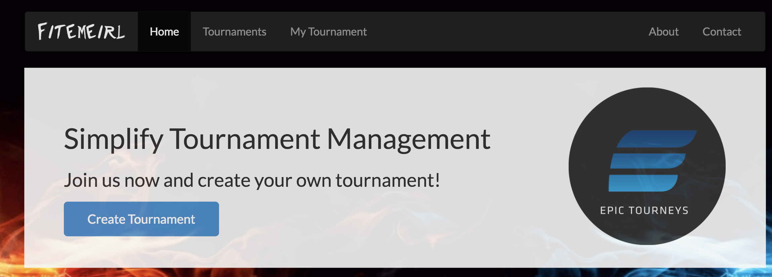

**Login:**

You can either login with existing credentials or click the Create your new account button to go to the account creation page.

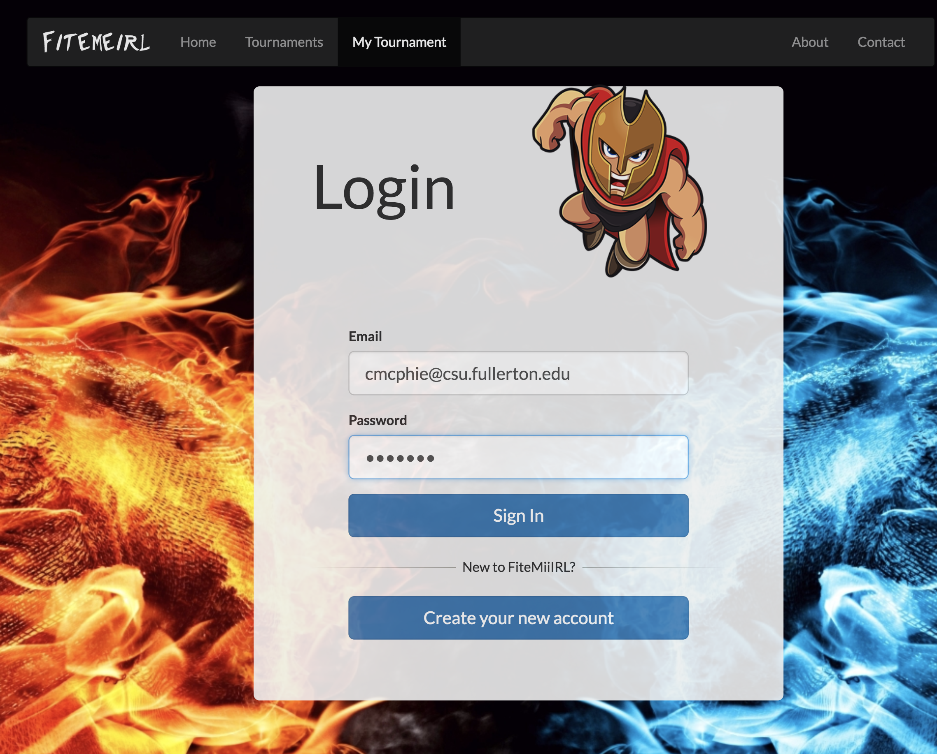

**Registration:**

Here you can register for a new account. All you need to do is put in your email, password, and confirmed password then click Sign up. If your registration is successful you will see the message in green at the bottom.

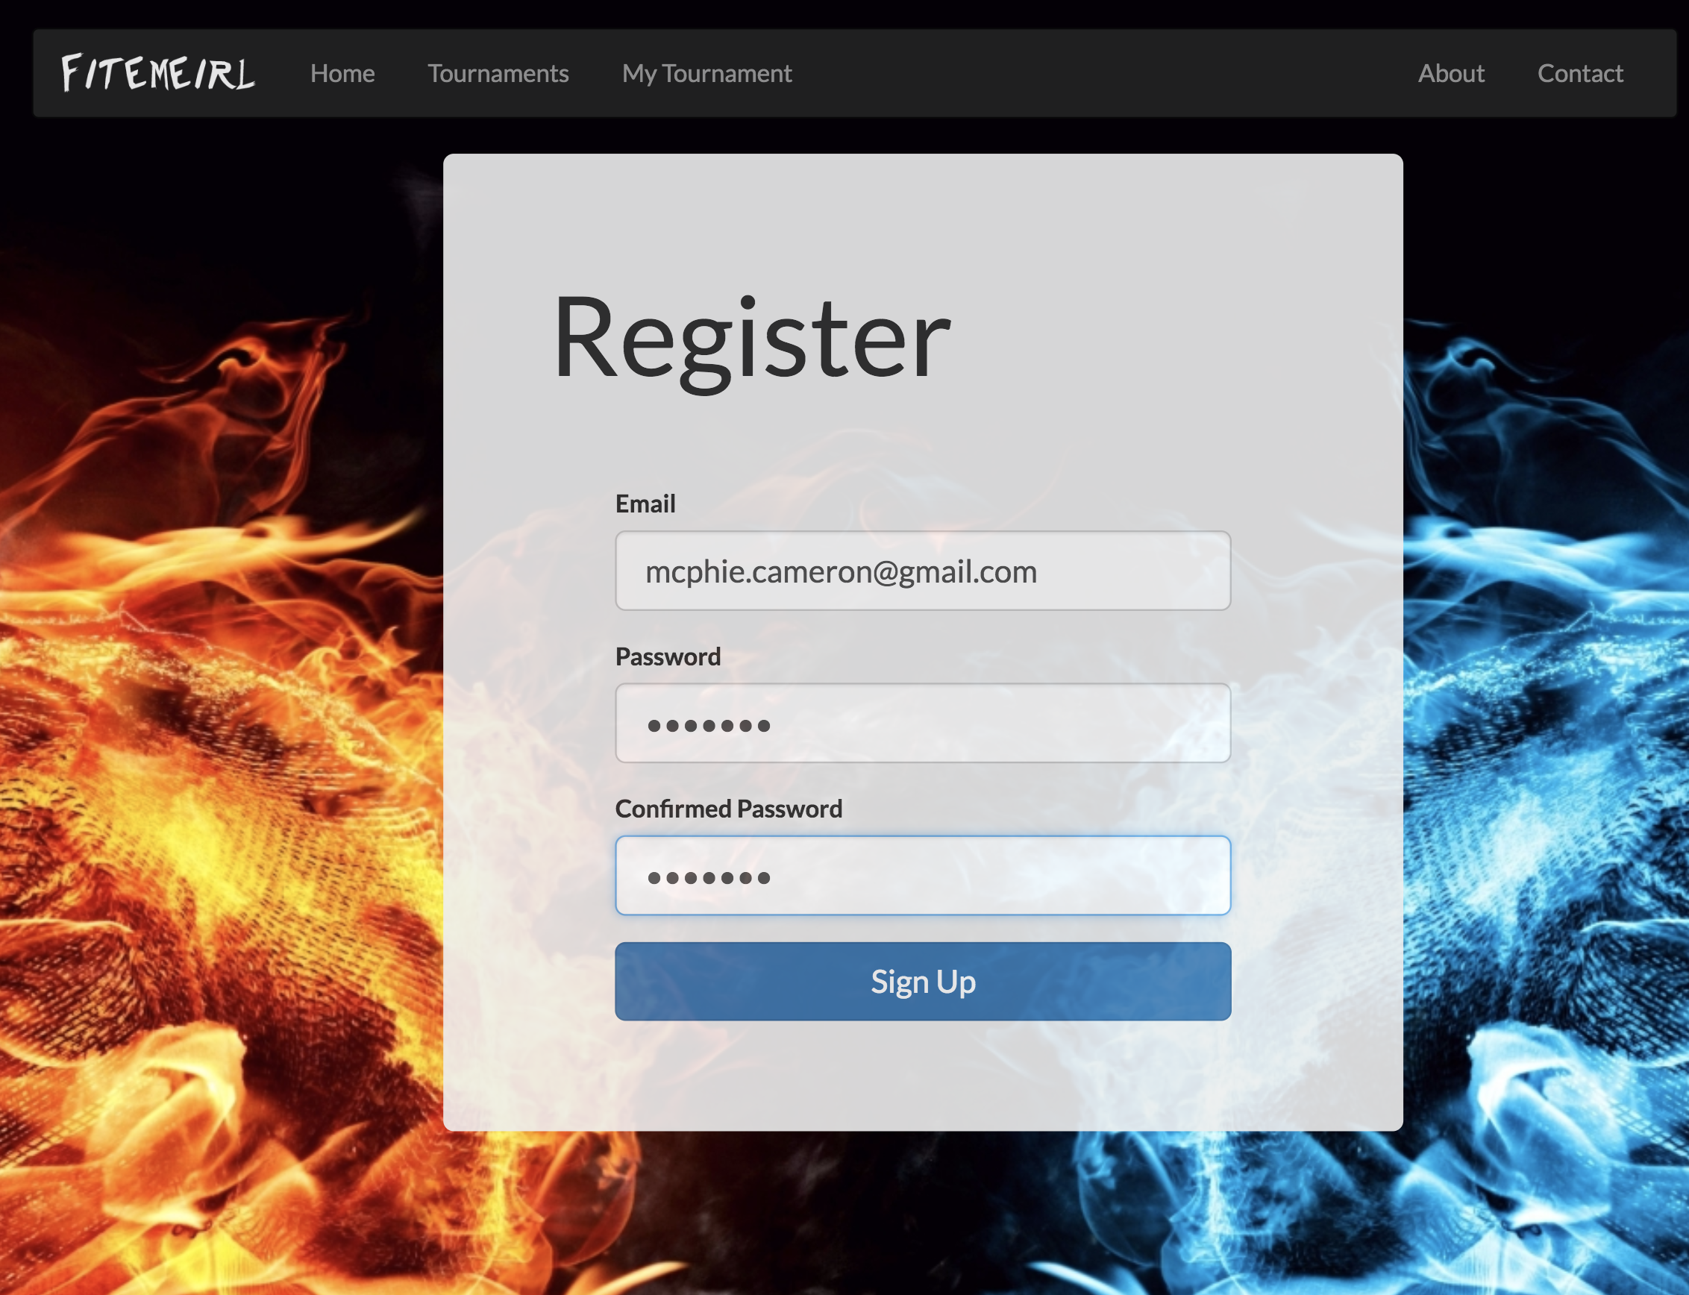

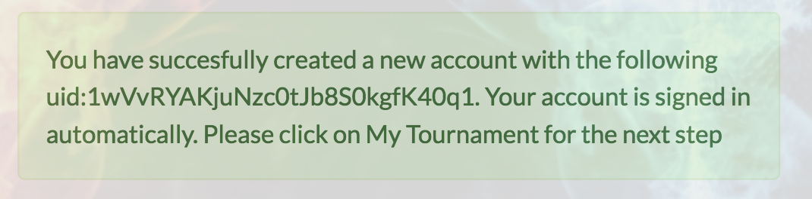

**Tournaments:**

This displays a list of all the tournaments that have been created by users, with the details about each of the tournaments and a map of the location of the tournament. If click the attend tournament while logged in, you will be added to the tournament list as an attendee. You can also click the Tourney Page link and see more details about the tournament.

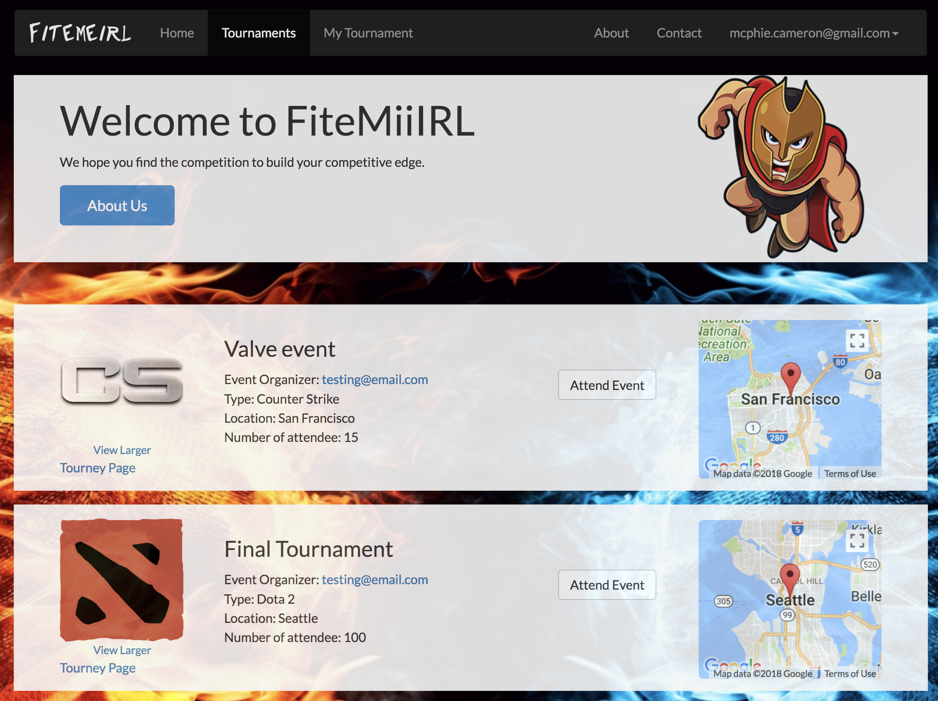

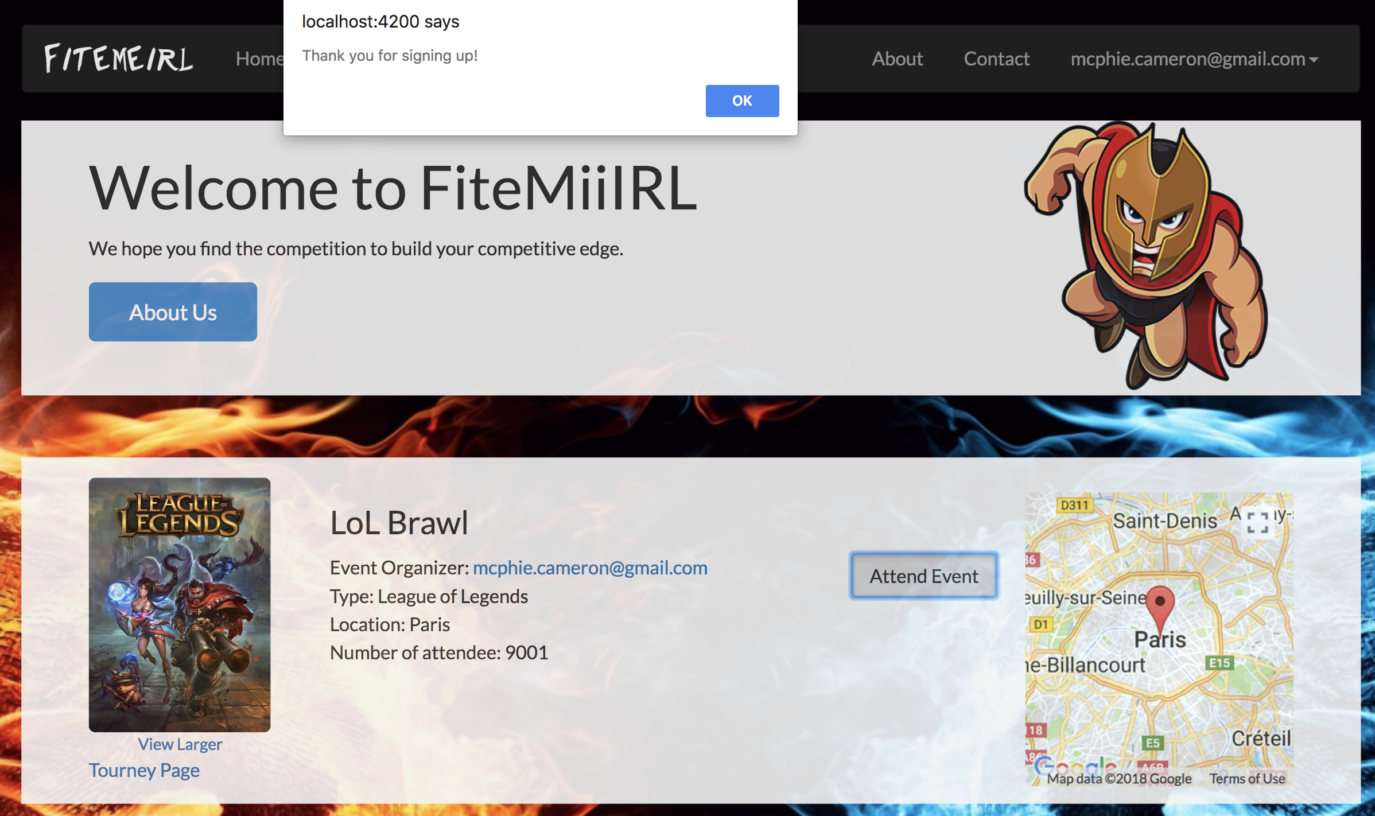

**Tournament Details:**

On this page, you can see more details about the tournament including the description and the attendee list.

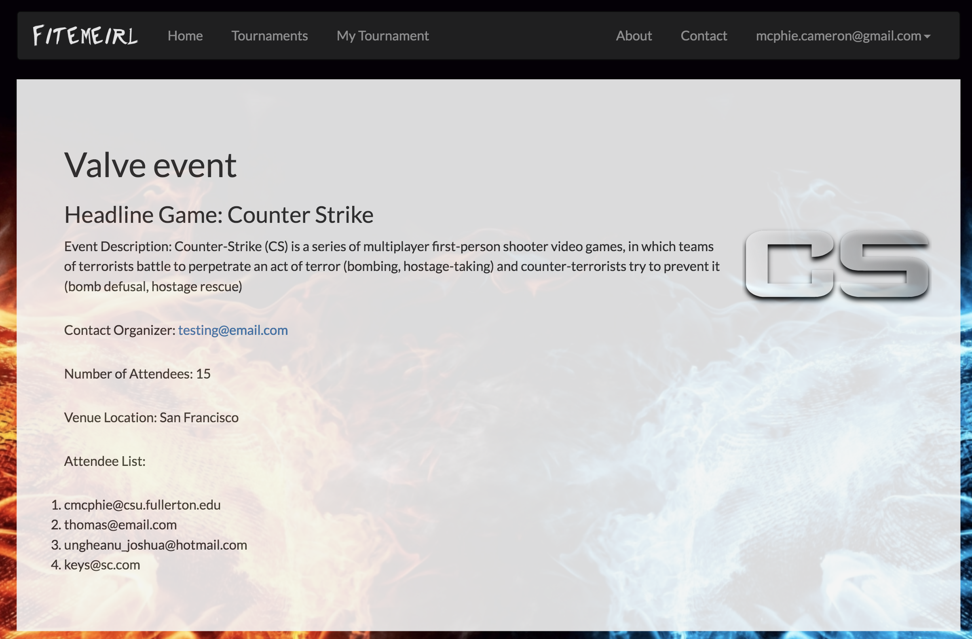

**Create Tournament:**

From the my tournament nav link, you can create your own tournament If you click Add new. You enter the details for the tournament and click the Create button and your tournament will be shown on the Tournaments page.

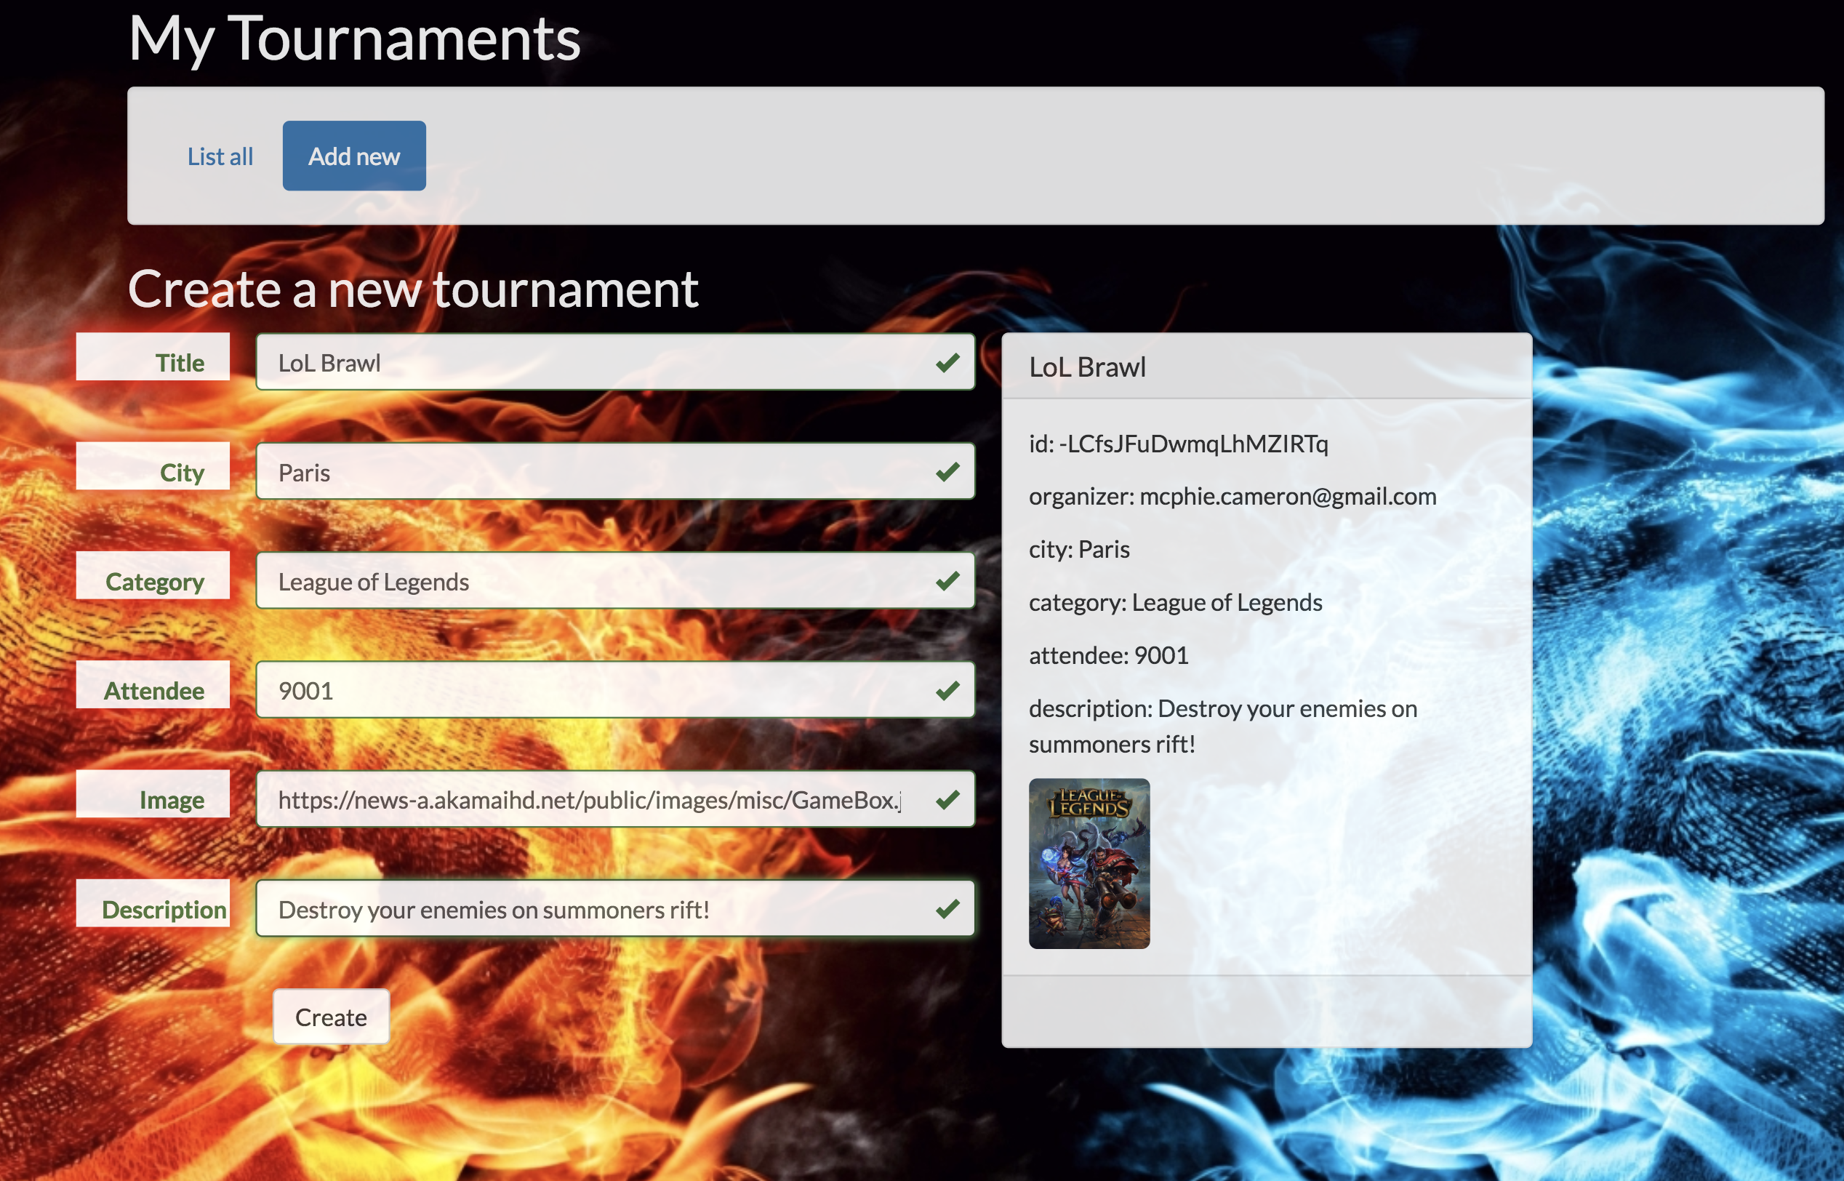

**Your Tournaments:**

Also, on the My Tournaments page you can see all the tournaments you have created.

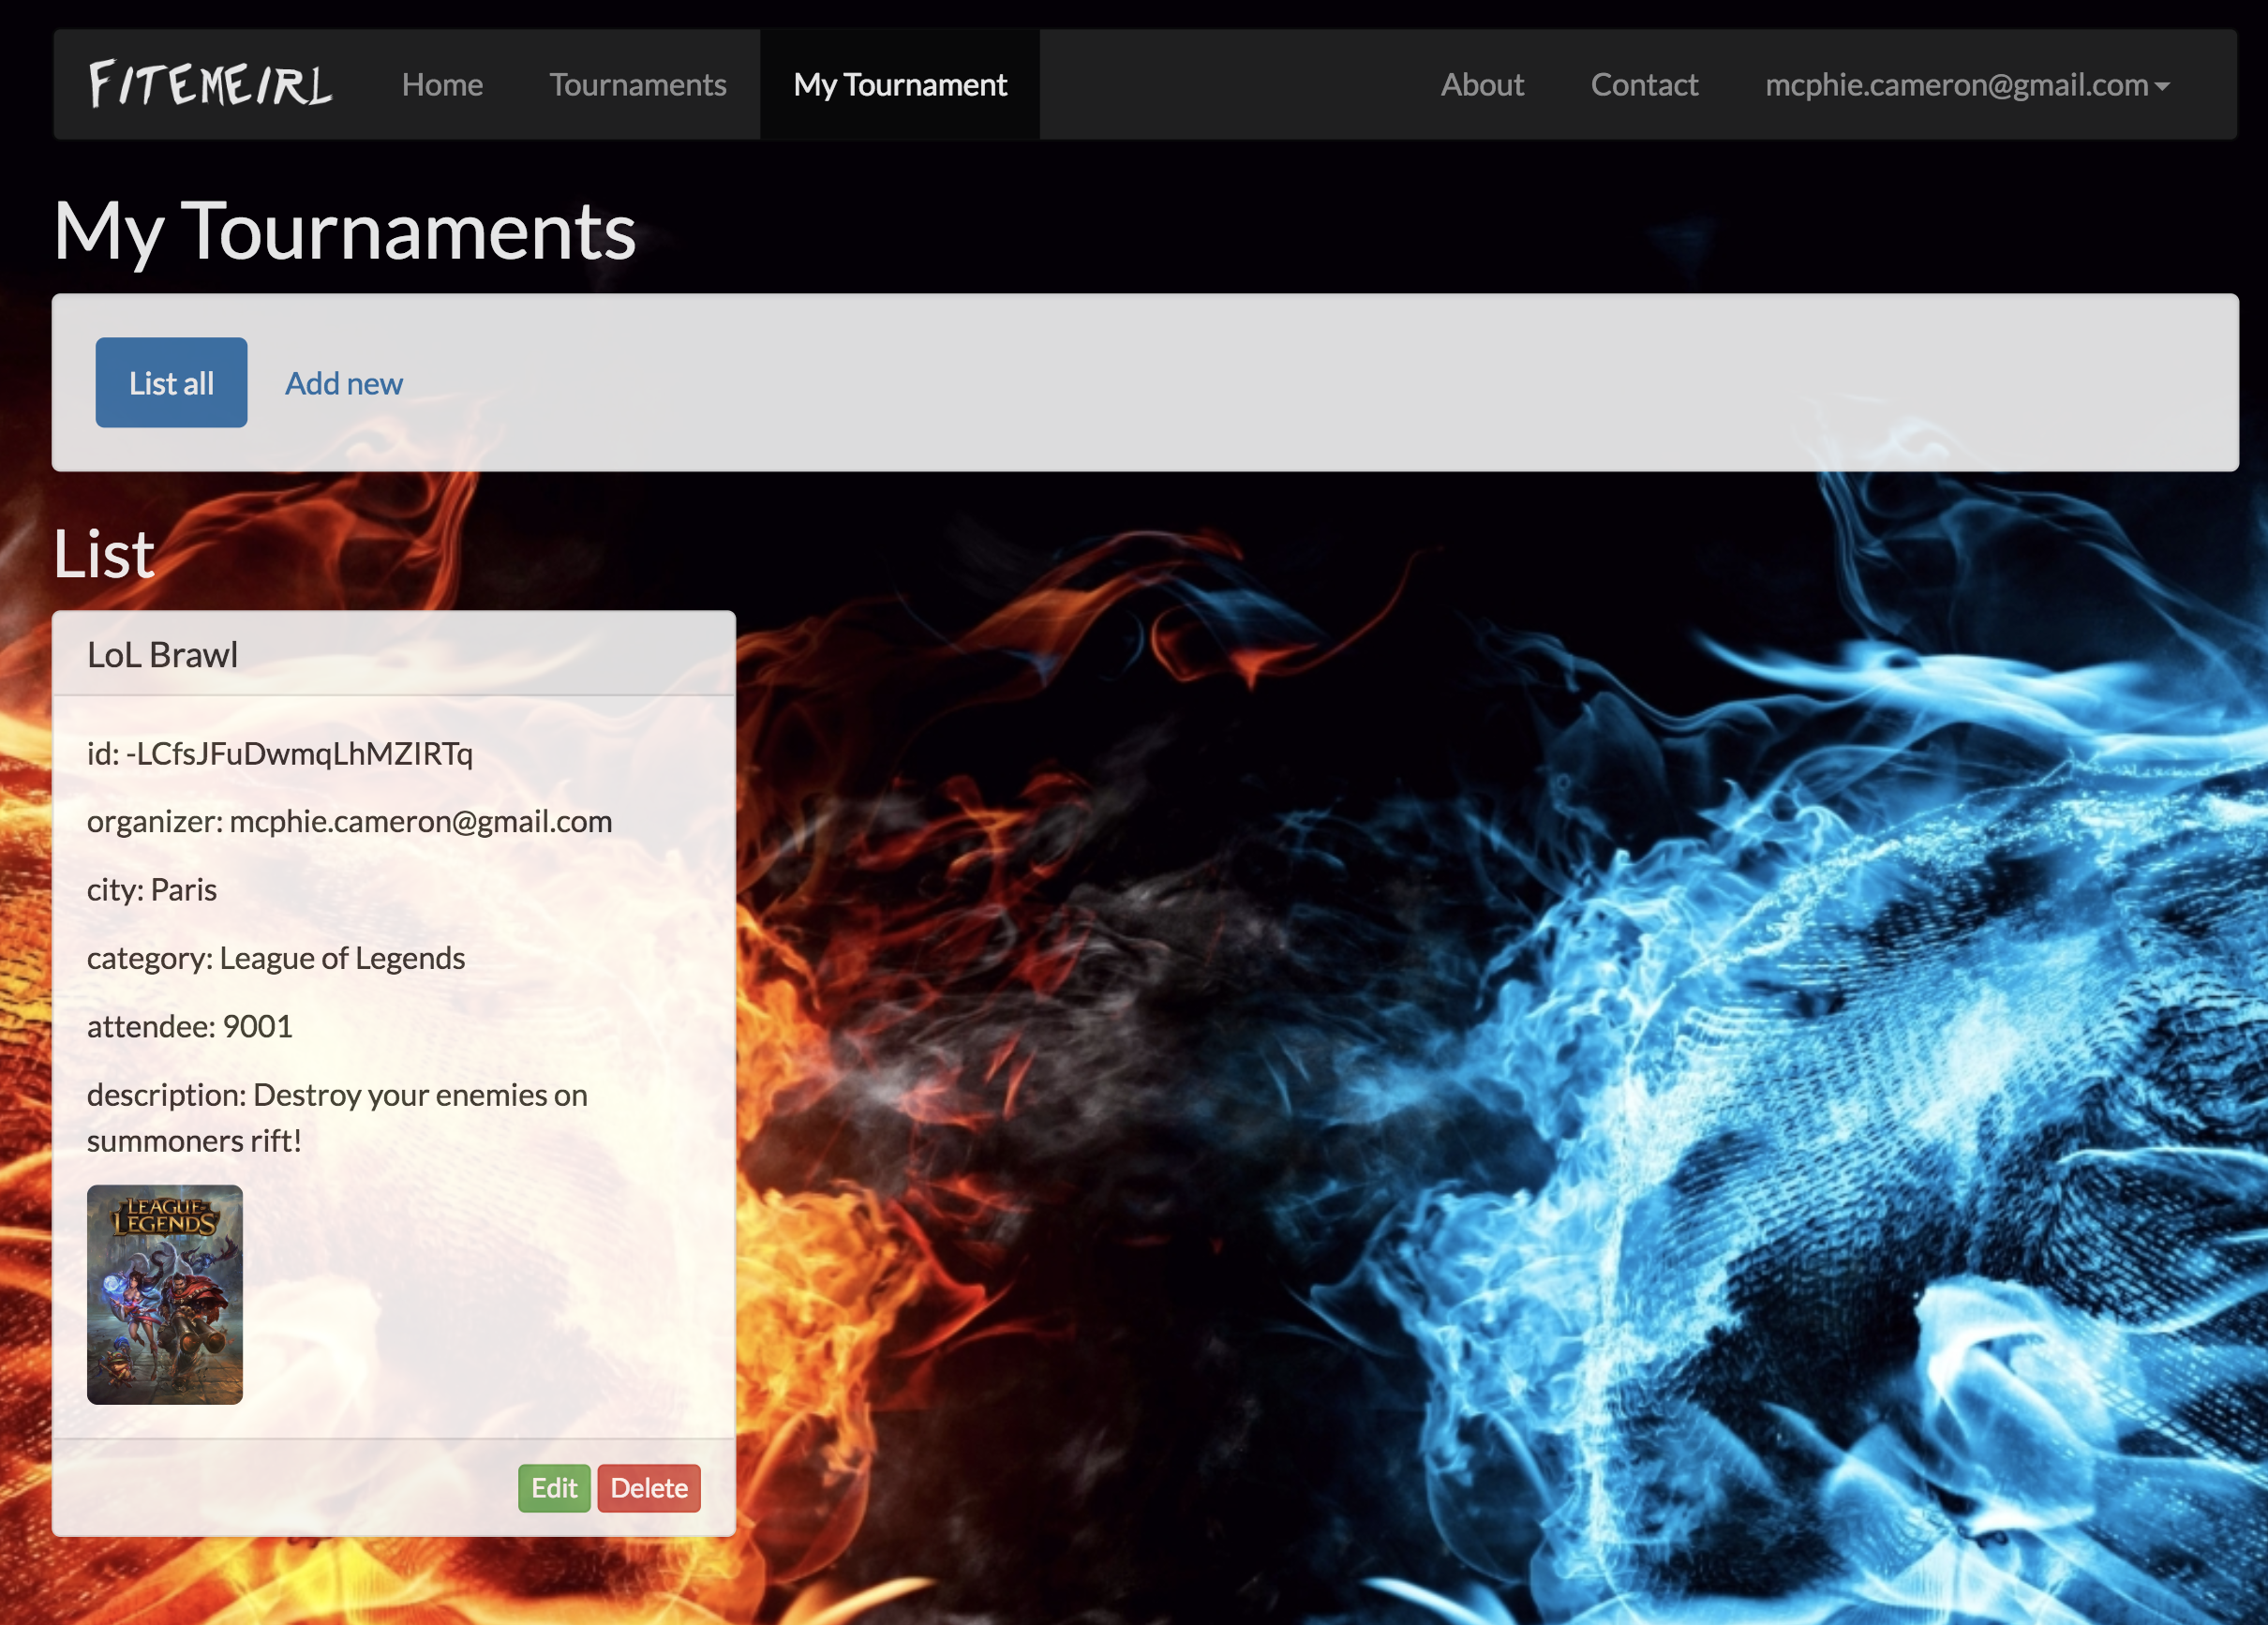

**About:**

A bit of information about our site.

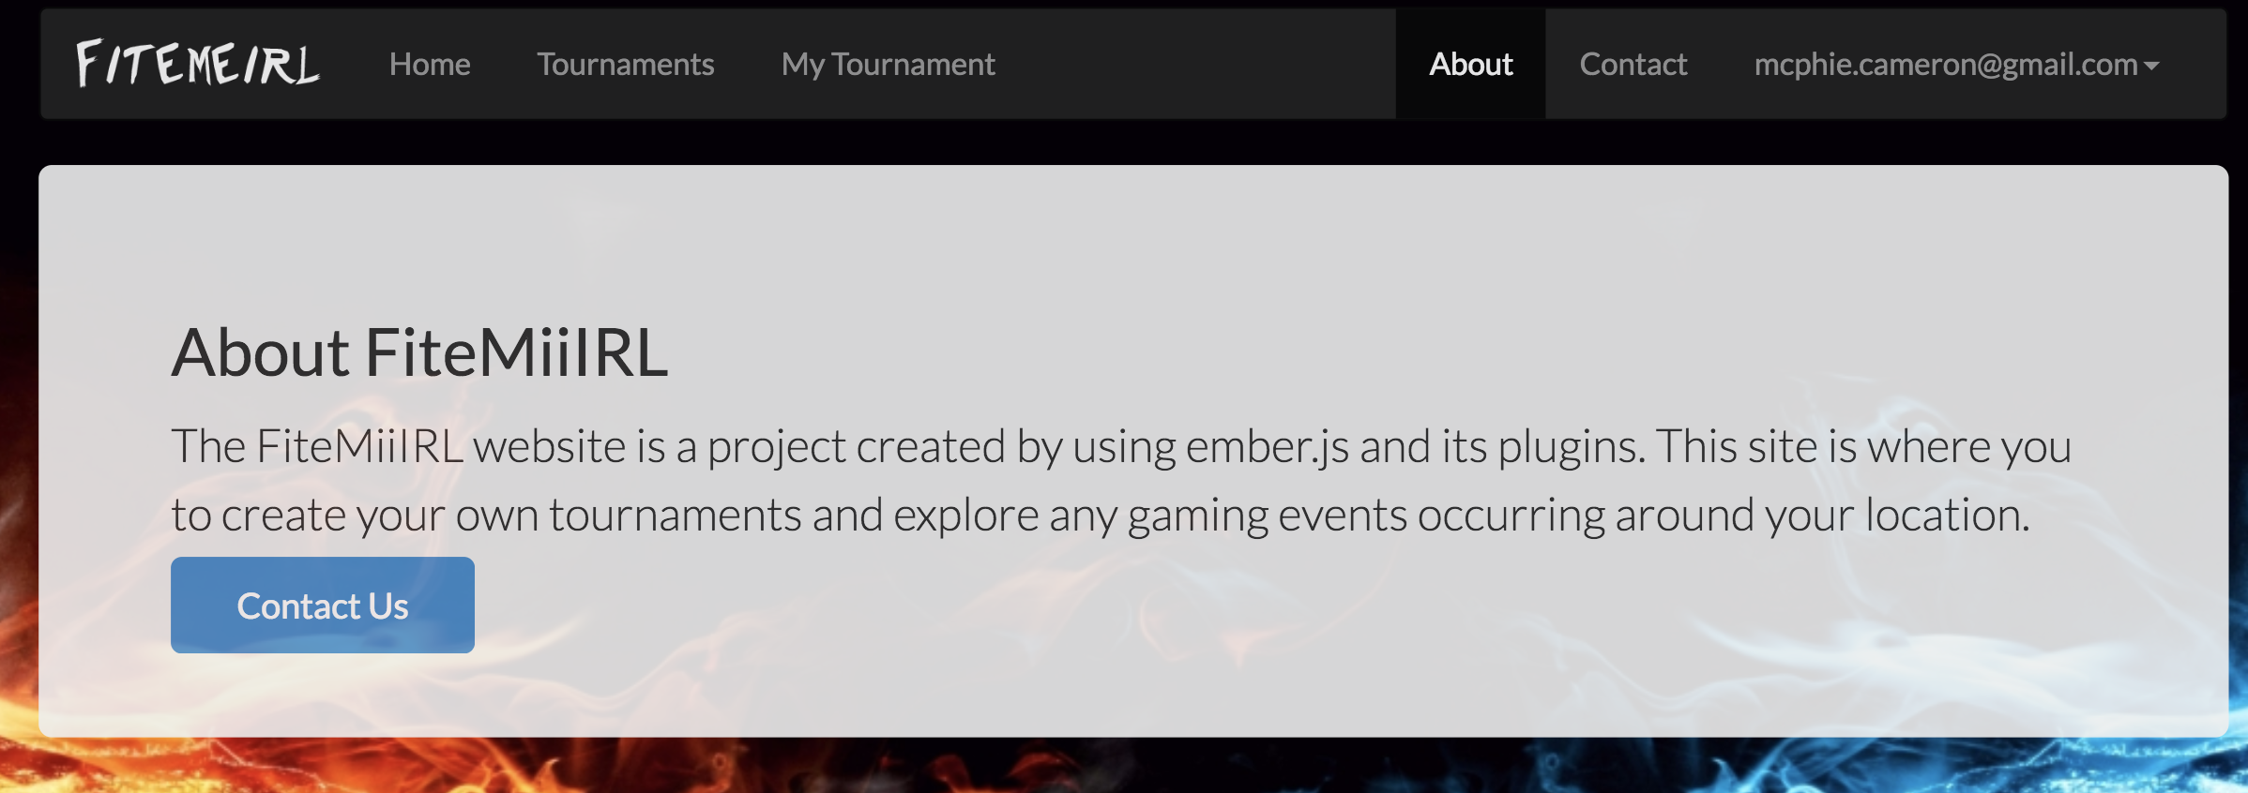

**Contact Us:**

Here you can find the information to contact us if you have any issues.

